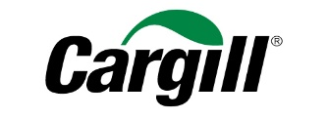
Cargill Protein Headquarters Local Art Overview

The design of the new Cargill Protein headquarters reflects both the business’ local roots and global impact. Local art, curated by Skliris Fine Art, is featured throughout the facility and incorporates local materials to create a welcoming, customer-centric, innovative, sustainable and dynamic space that highlights Cargill Protein’s growing brand and storied history.

The Cargill brand, its people, and the impact of the protein business are celebrated thoughtfully throughout the new space using creative graphics, art installations and custom photography that honors the business’ values and the site of its headquarters.

These installations include:

The Great Hall – As the office’s central gathering space and primary conference center, the Great Hall tells the story of Cargill Protein. A triptych, with three images forming one large display, features an image which shows cows grazing the Flint Hills in the distance, with a dinner scene in the foreground, paying tribute to the process of “land to table.” Wichita photographer Gavin Peters created the scene with the help of a regional rancher.

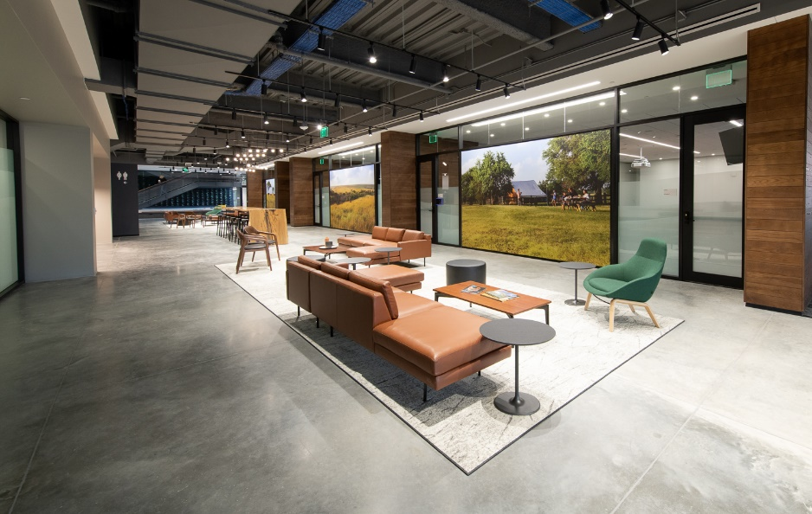
The Great Hall

Plate Installation – A 28-foot wide custom art display of ceramic plates serves as the backdrop to the open central staircase that connects all four floors of the building. 800 plates were commissioned from local ceramicist Greg Lathrop and are all hand-thrown using local clay. This installation represents Cargill Protein’s values with the use of humble materials made into dinnerware to symbolize where Cargill Protein’s work meets the consumer. A subtle green gradient in the glaze along the stairway echoes the forms of the Flint Hills.

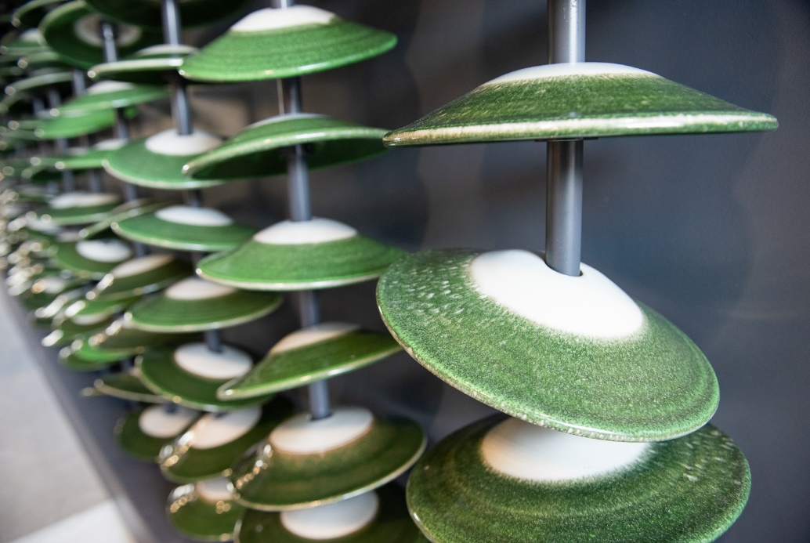
Plate Installation

Level 4 Imagery – Two dinner scenes are showcased on the fourth floor, showing how people enjoy meals both in their homes and outside of them. These images feature Cargill Protein brands and were shot by local photographer Gavin Peters at Cargill’s culinary innovation center nearby.

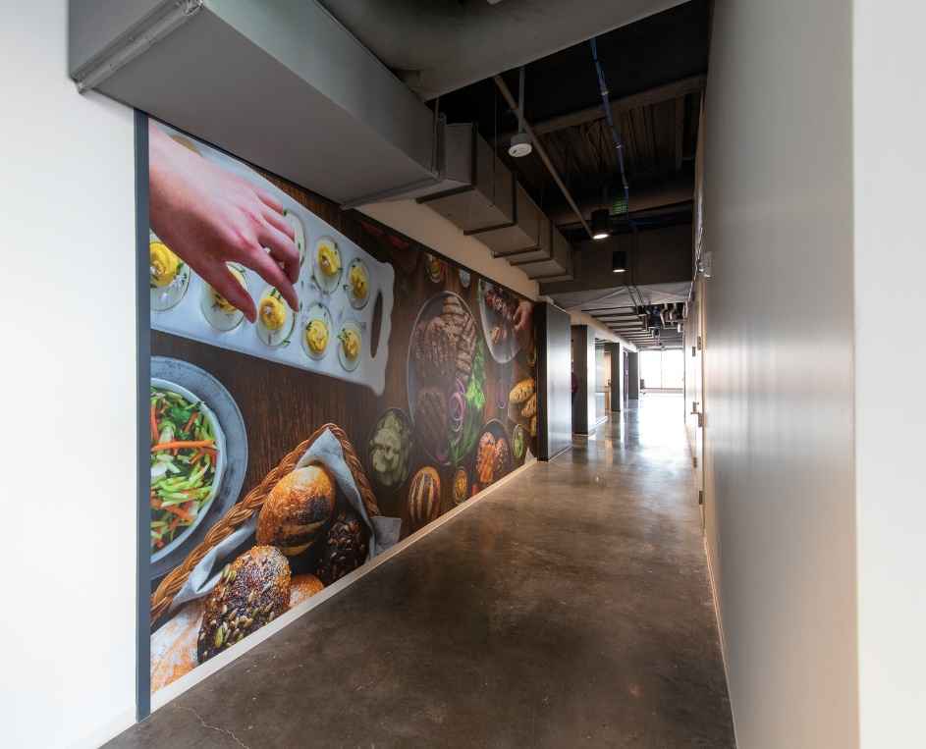
Level 4 Imagery

Café Wall – The café wall highlights Wichita landmarks and Cargill Protein’s pride for its home city. The custom drawings by HOK, feature iconic elements of the city including the Keeper of the Plains Statue, the Santa Fe Railroad Train, Wichita flag, regional plant life, and a vignette showing a Boeing plane flying over the city.

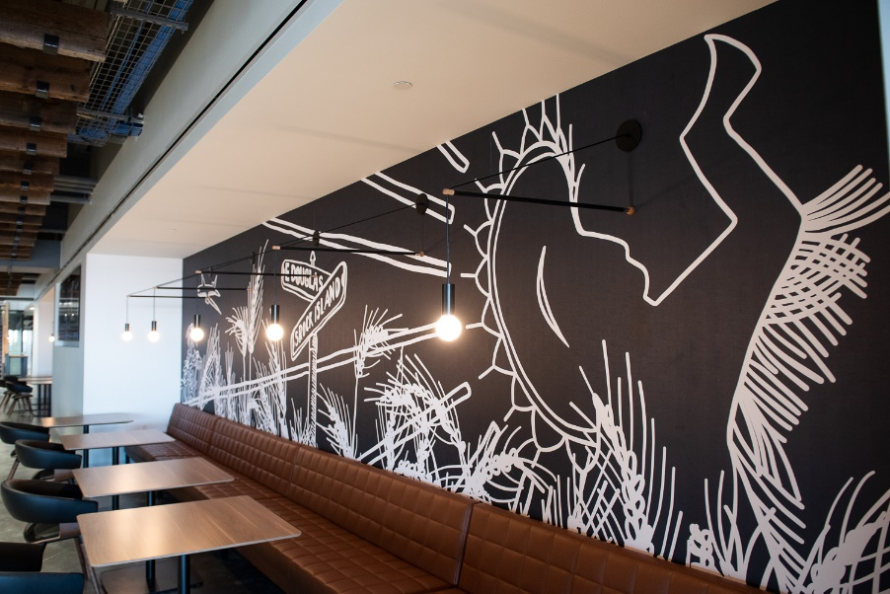
Cafe Wall

Courtyard – The courtyard features a large, painted mural adjacent to an outdoor gathering space for employees. This mural features the words “grow” and “gather,” speaking to the essence of Cargill’s process as well as the purpose of the courtyard. There’s even a nod to the past – the EXCEL sign.

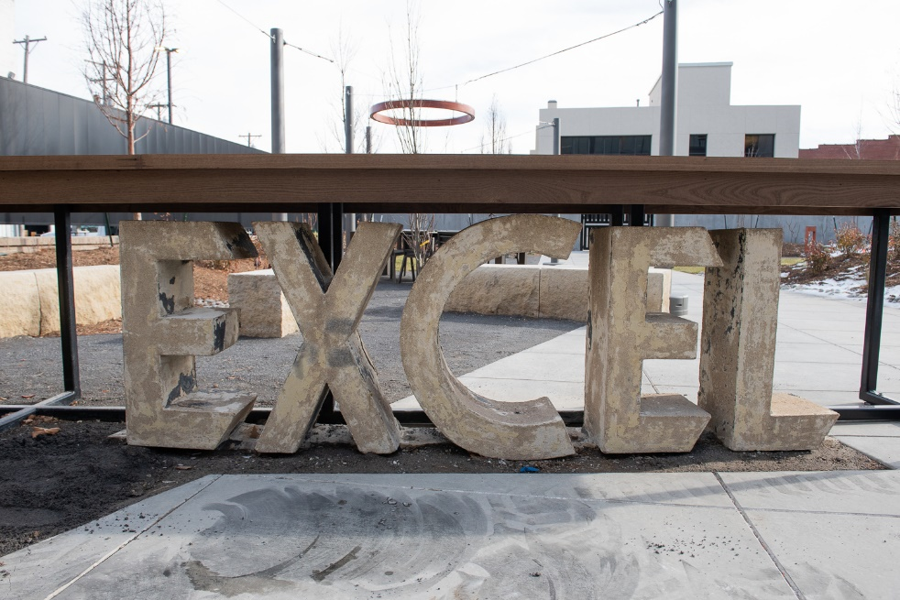
Courtyard

Sustainability Rooms – At the far end of the conference center, facing Old Town, three rooms honor Cargill’s commitment to sustainability. These curated spaces are animal, earth and legacy themed. Each room features custom tables and millwork, unique environments, and imagery that visualizes Cargill’s sustainability priorities.

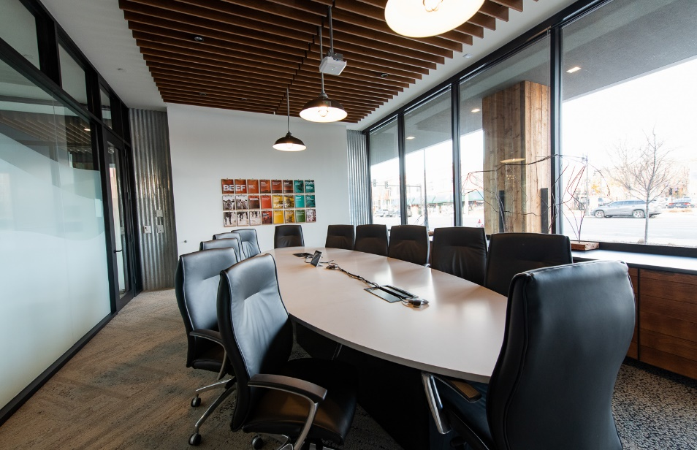
Sustainability Rooms: Animal

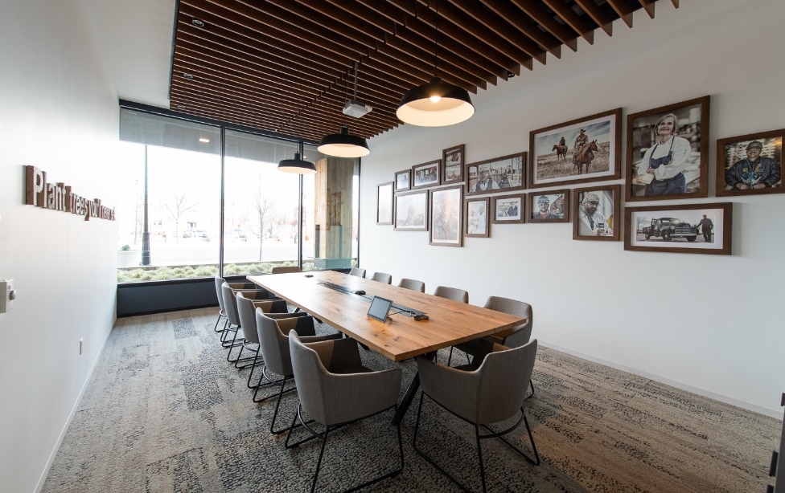
Sustainability Rooms: Legacy

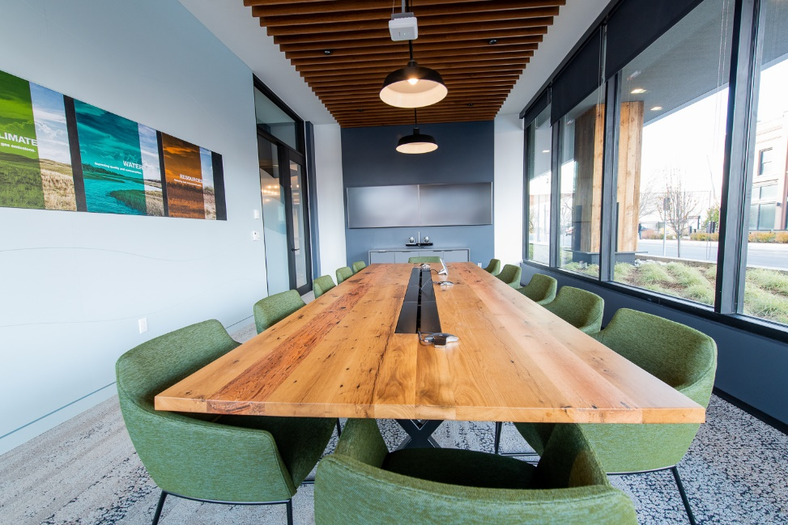
Sustainability Rooms: Earth

Trading Floor Imagery – The trading floor images pays homage to those employees who work hard behind-the-scenes and showcase Cargill’s plant employees. This imagery is intended to connect trading floor employees to the whole Protein process and celebrate their work.

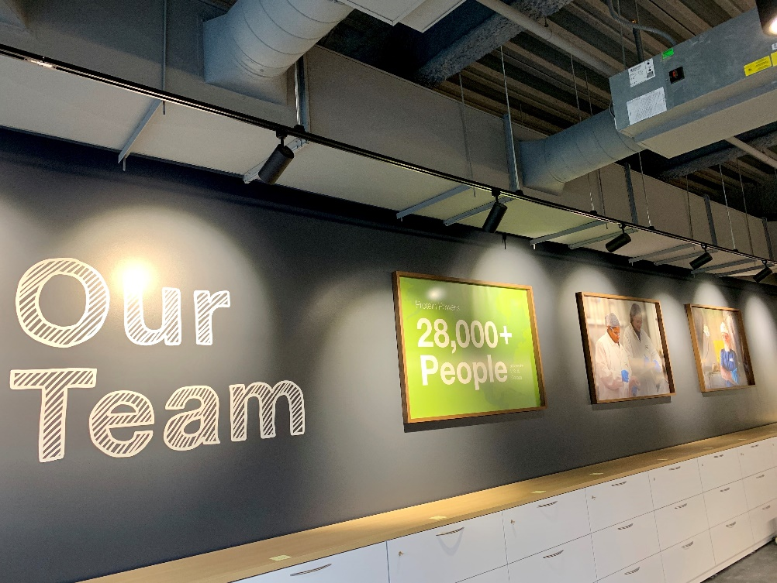
Trading Floor Imagery

Employee Entrance – The employee entrance was thoughtfully designed with rope to create an abstracted three-dimensional landscape mural – authentically paying tribute to the materials of a rancher.

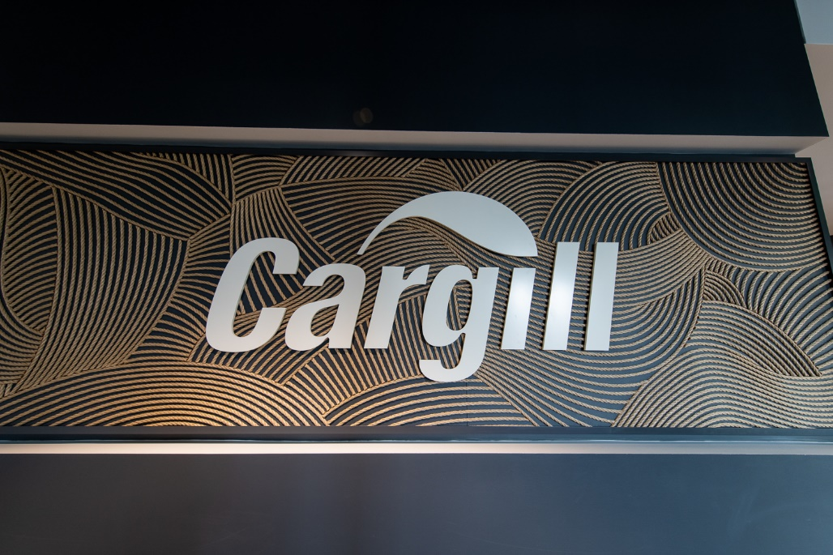
Employee Entrance

Art Work – Artwork from local artists has been curated and incorporated throughout the space.

